**USER’S MANUAL**

**Excel to CSV - Importing Members To Database**

**October 2025**

Table of Contents

I. USER’S MANUAL 2

Screen shot of output with description 3

Dark Mode / Light Mode Themes 3

Instructions on how to use: 4

Keyboard Shortcuts 10

Sample Tooltips 10

II. Download version 1.0 release: 11

III. Installation instructions 11

IV. Video Demo: 17

# USER’S MANUAL

## Screen shot of output with description

## Dark Mode / Light Mode Themes

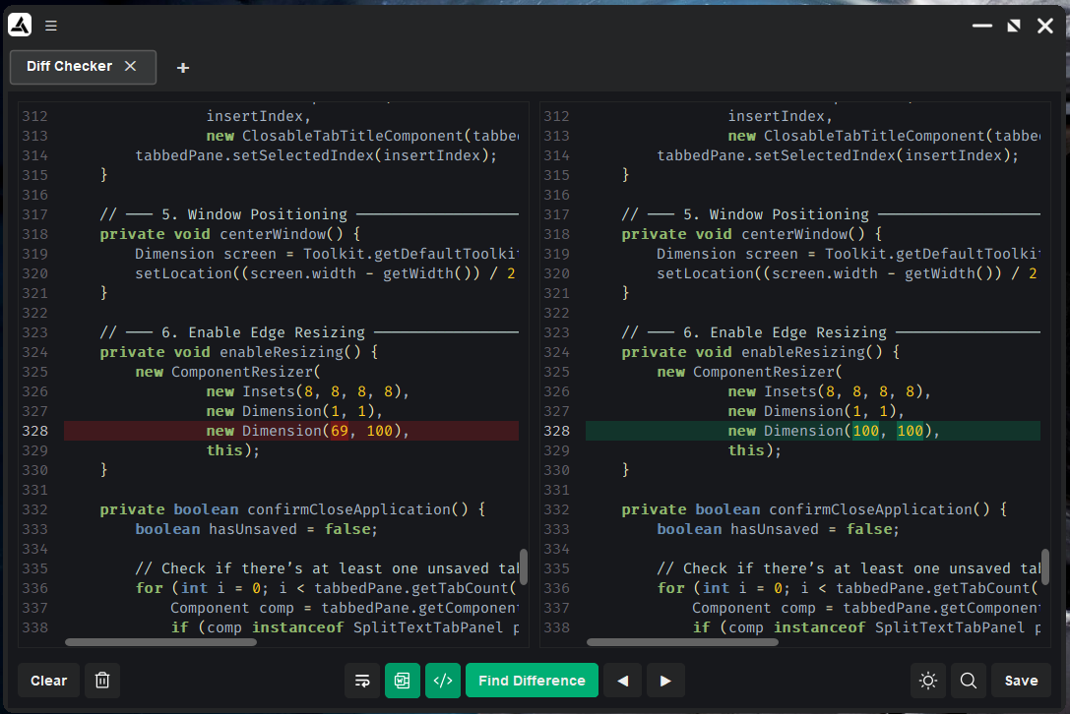

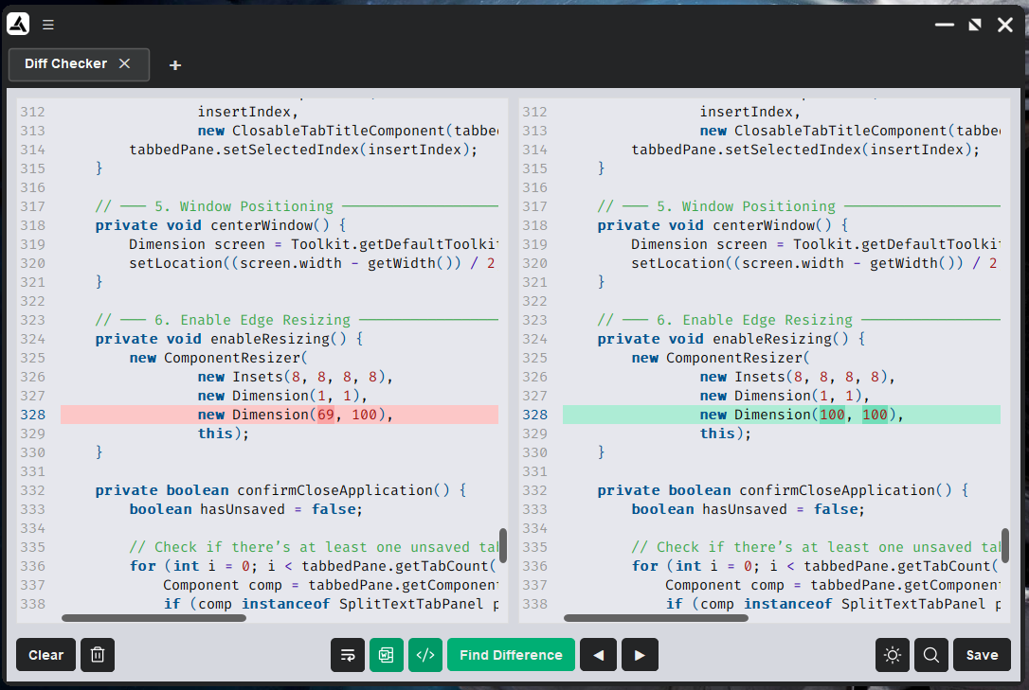

## Instructions on how to use:

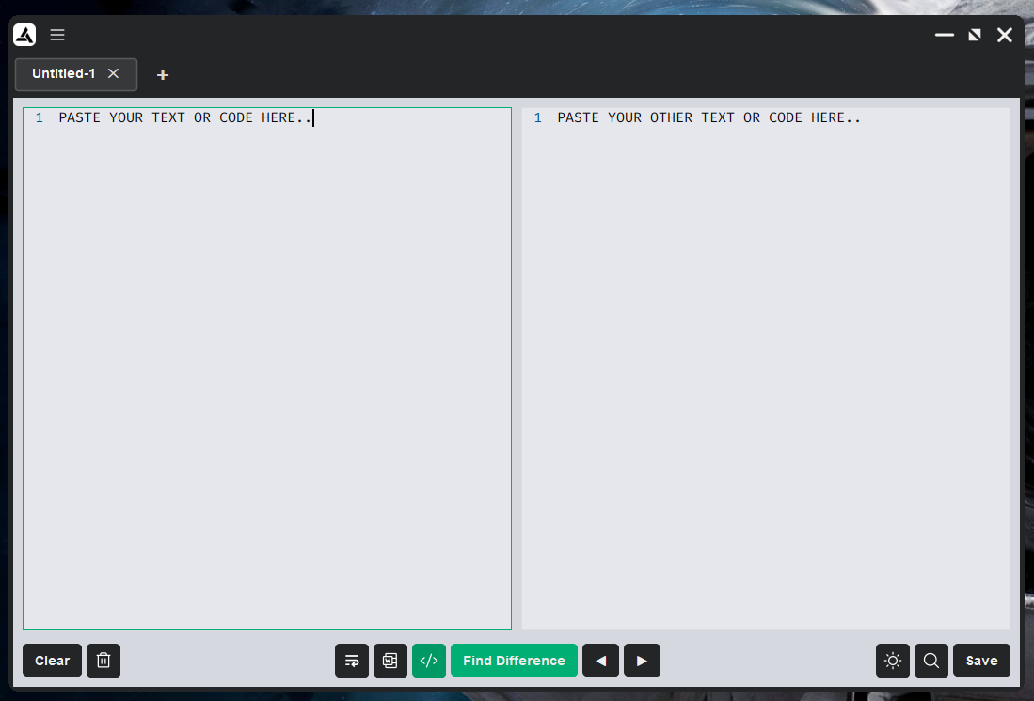

**Figure 1** To start, paste your two differing texts individually on each text editors / code editors

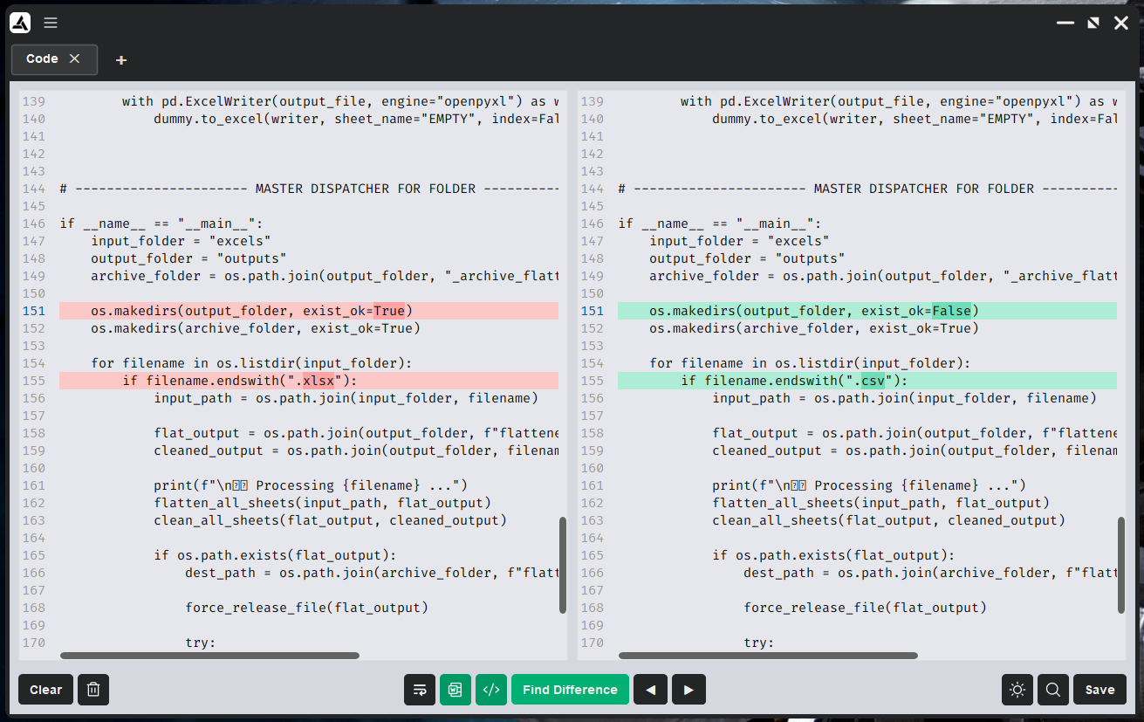

**Figure 2** After pasting your two differing texts into the text editors, click the “Find Difference” button to highlight texts that are different from each other. You can also cycle through the next or previous other differences using the “Arrow” buttons

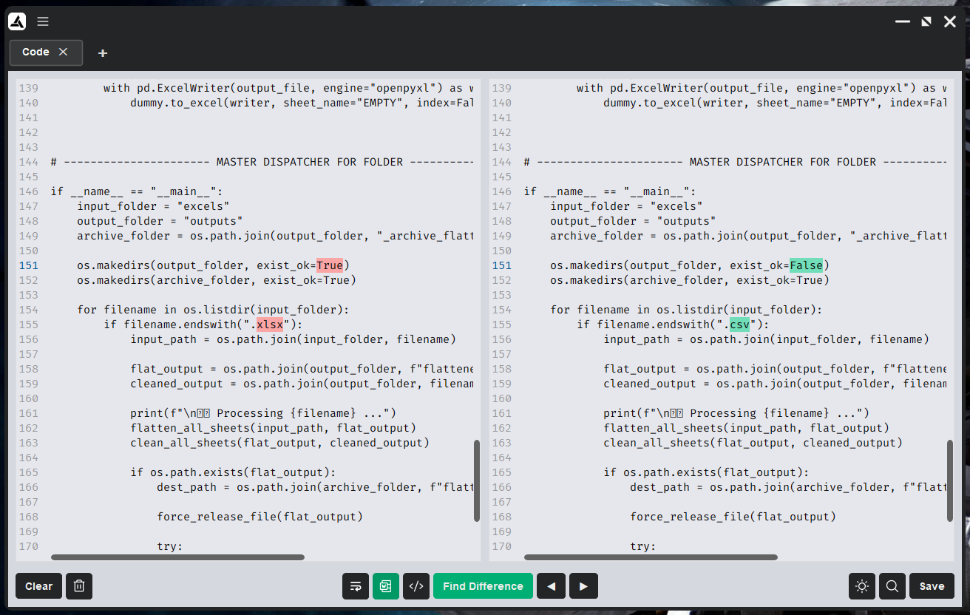

**Figure 3** To easily see which words are different you can toggle off the line highlight by pressing the Toggle line highlight button denoted by these characters "</>"

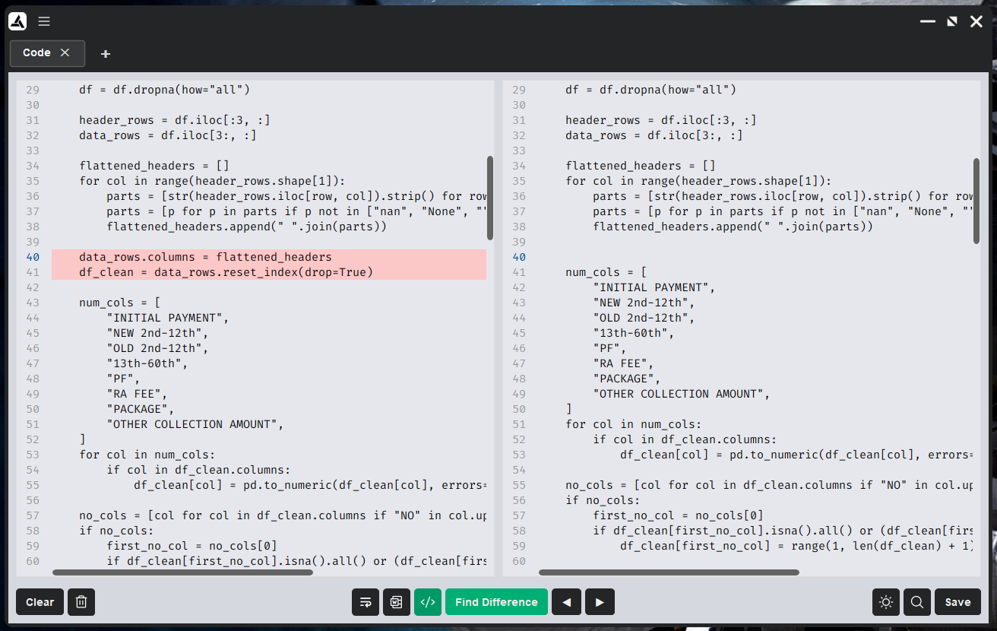

**Figure 4** In some cases there are texts or codes that are completely absent from original text that you have pasted. You can easily spot those by toggling Line Highlight on.

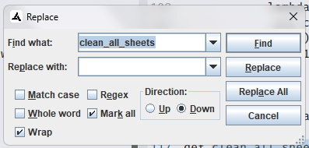

**Figure 5** Sometimes, there are cases wherein you would need to find and replace some texts. You can easily do that by pressing the Magnifying glass button or by hitting Ctrl + F on your keyboard.

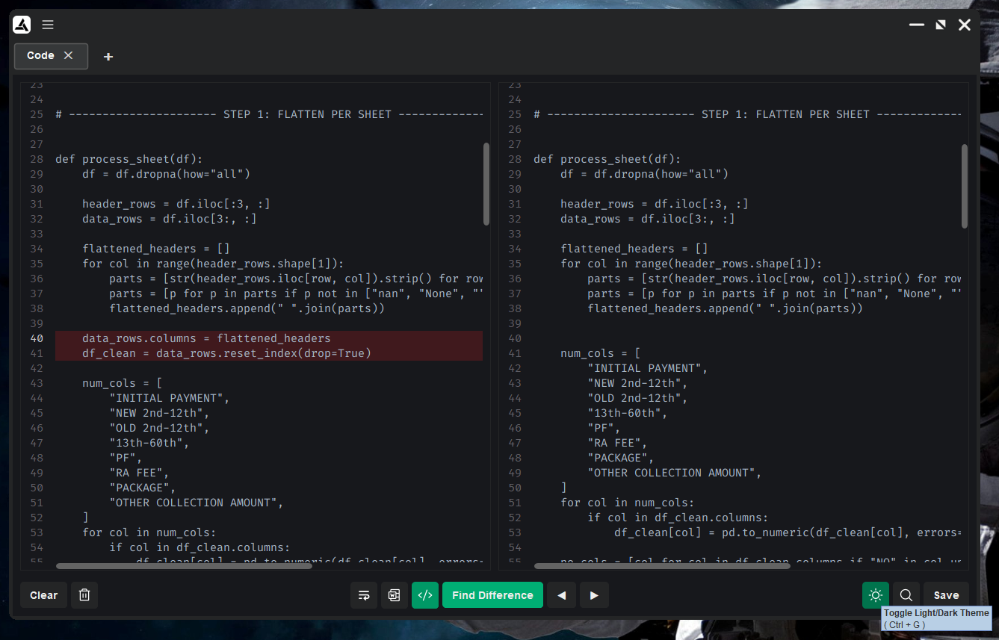

**Figure 6** Sometimes, there are also cases wherein you want to not strain your eyes especially on long hours of coding. You can turn on Dark mode hitting Ctrl + G or clicking the sun button.

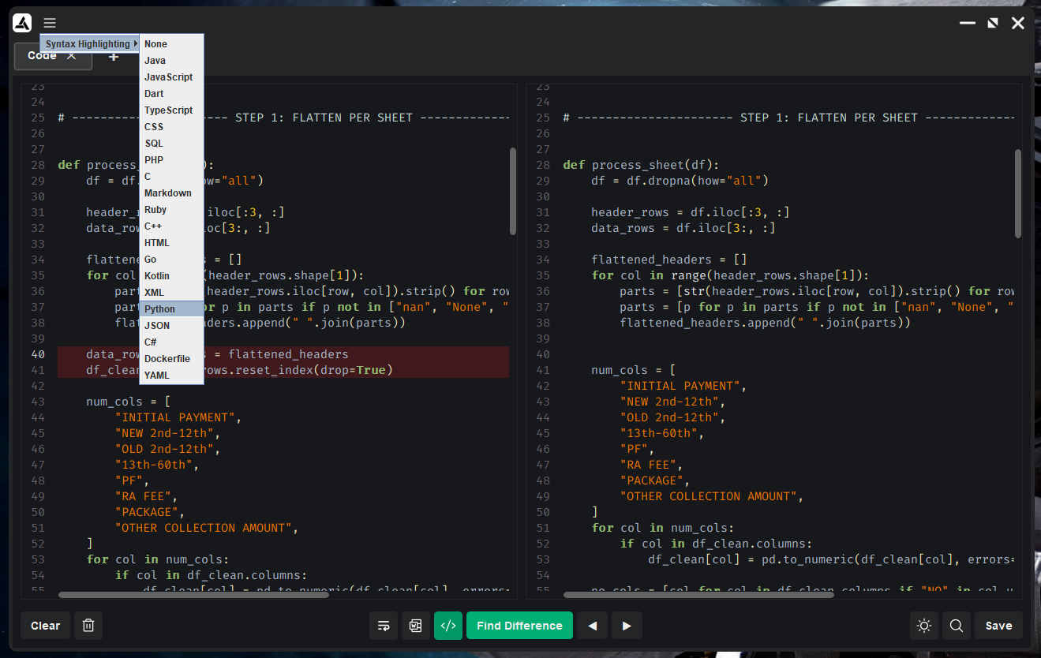

**Figure 7** You can also turn on the Code Editor feature by turning on the Syntax highlighting via menu button up top on the title bar.

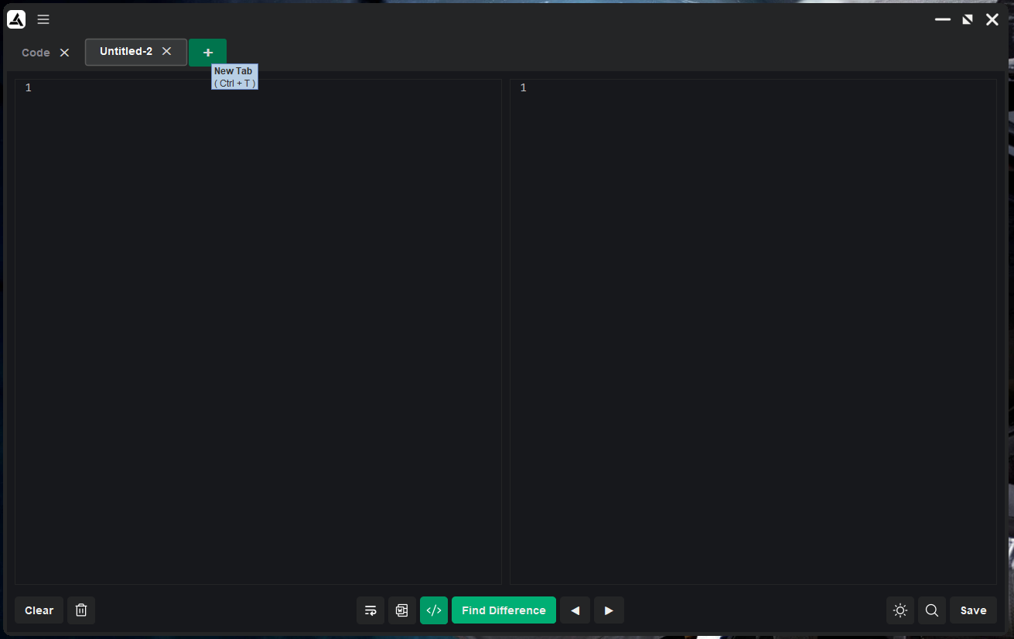

**Figure 8** You can open a “New Tab” by pressing Ctrl + T or by click the Add New Tab “+” button

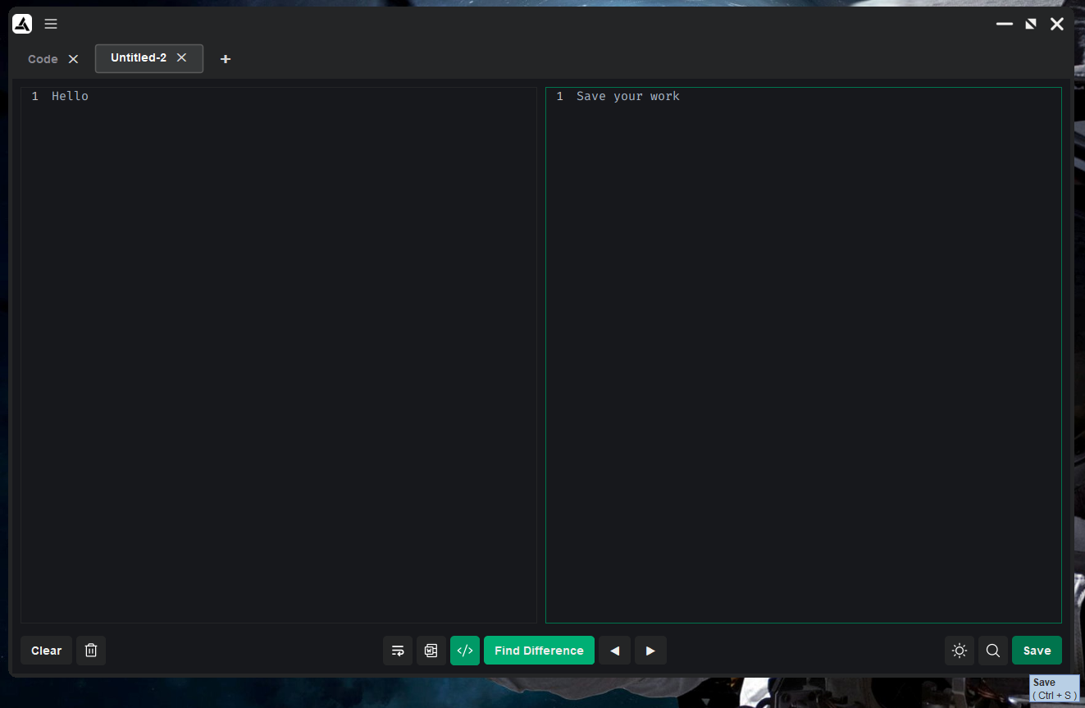

**Figure 9** You can save your work into the SQLite database by either clicking the Save button or pressing Ctrl + S

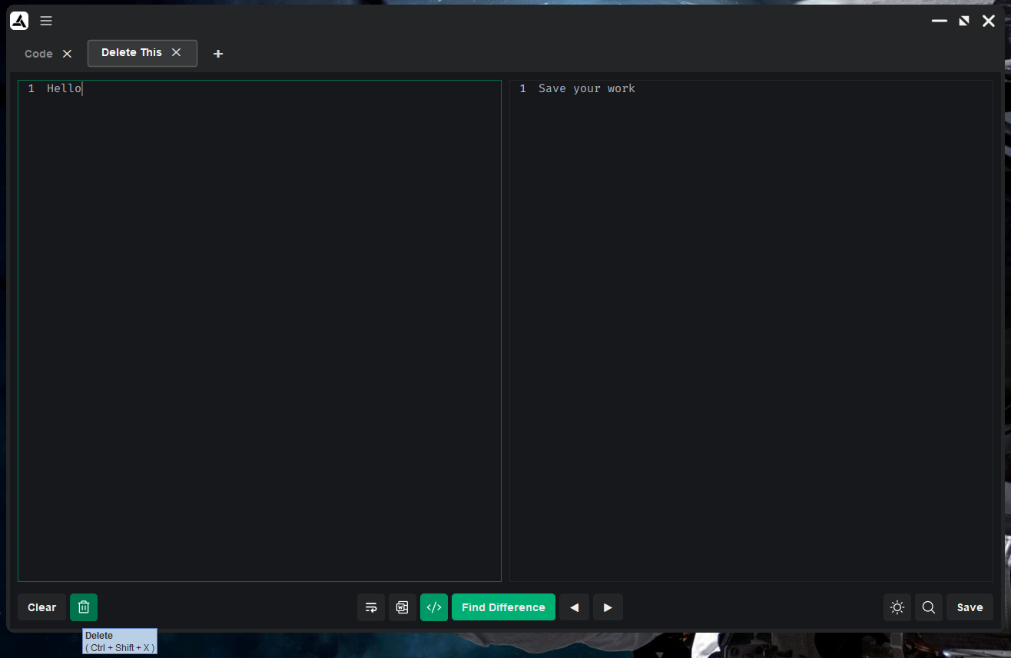

**Figure 10** You can delete your work by pressing Ctrl + Shift + X or clicking the trash icon

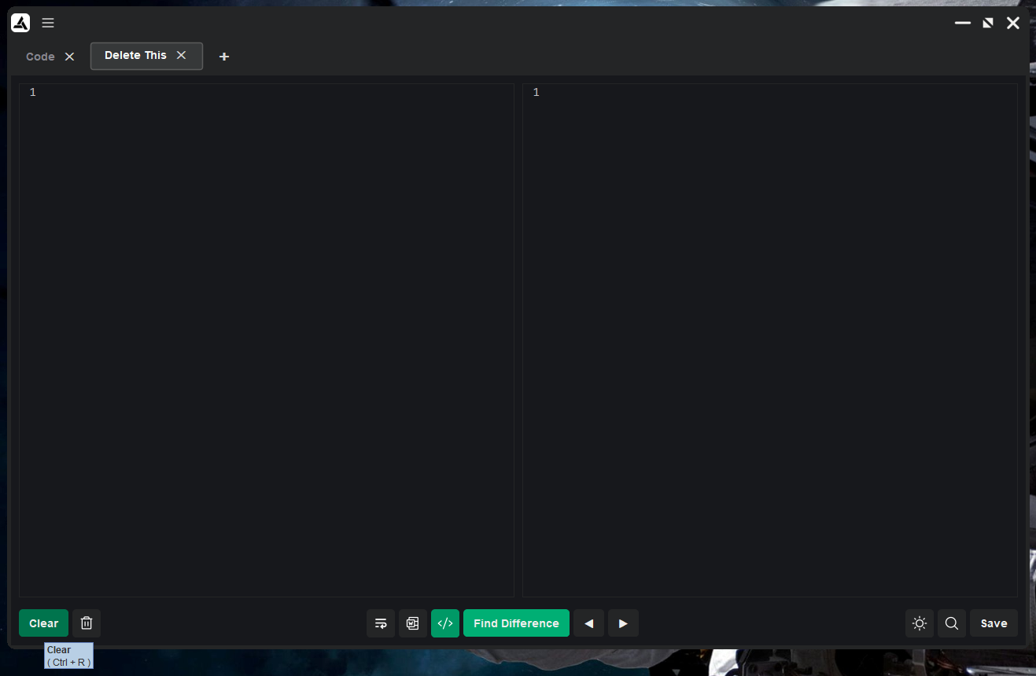

**Figure 11** Finally, to clear everything on both of the editors at the same time you can press Ctrl + R or hit the Clear button

## Keyboard Shortcuts

* **Alt + Shift + Enter:** Find difference between two texts
* **Alt + E:** Toggle line highlight
* **Alt + W:** Toggle word highlight
* **Alt + Q:** Toggle wrap
* **Ctrl + G:** Toggle light theme/dark theme
* **Ctrl + S:** Save
* **Ctrl + F:** Find/Replace
* **Ctrl + Shift + X:** Delete tab from database
* **Ctrl + R:** Clear texts from both Text Editors
* **Ctrl + W:** Close current tab

## Sample Tooltips

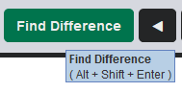

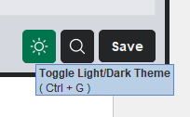

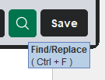

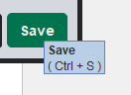

# Download version 1.0 release:

[Download installer here](https://github.com/rising-dancho/excel_automation_ffpi/releases/download/v1.0.0/setup.exe)

# Installation instructions

* about the **"Run anyway"** screen, in order for me to remove ***that*** warning for this desktop app i would need to pay a trusted Certificate Authority for a **"Code Signing Certificate" (around $70 – $500 PER YEAR)** from Sectigo (Comodo), GoDaddy, SSL.com etc. in order for Windows to not flag me as an **"Unknown Publisher."**
* this is a ***free*** tool

**Download the installer**

[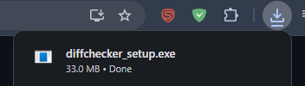](https://private-user-images.githubusercontent.com/43742265/482815720-c8e882d8-0f2e-4dcb-a795-d0aebda2ca01.png?jwt=eyJ0eXAiOiJKV1QiLCJhbGciOiJIUzI1NiJ9..oZ4BGFXMaGtne6FJ8jOyIZyzY3xIFikojAGYu4geN_M)

Click "More Info" > "Run anyway"

[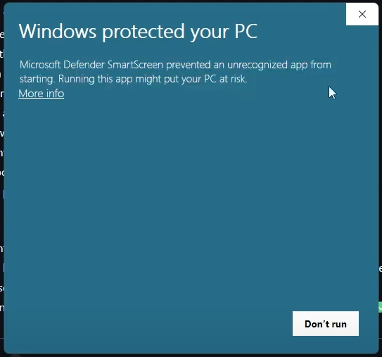](https://private-user-images.githubusercontent.com/43742265/482816484-2c90a250-36eb-41c4-8db3-79f7e58ba789.png?jwt=eyJ0eXAiOiJKV1QiLCJhbGciOiJIUzI1NiJ9..ec3JLItVGOMkWJE-kA-QGhkgvfvIov8s_V8c2ffo31A) [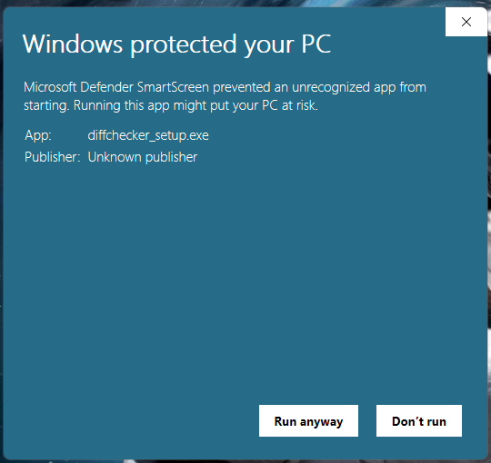](https://private-user-images.githubusercontent.com/43742265/482818321-27f83a24-e370-40d2-861e-5b14bfe3528a.png?jwt=eyJ0eXAiOiJKV1QiLCJhbGciOiJIUzI1NiJ9..YxrGkE76vyLIFnaENm_zSYiVzcaoji8MZZgWm7nIFis)

After that just proceed to your normal installation, hit "Next" until you see the "Finish" button

[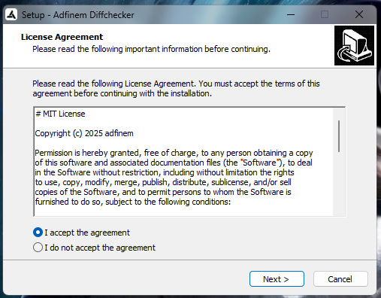](https://private-user-images.githubusercontent.com/43742265/482819092-8b0af58f-abae-4b11-b45c-1e084d99585b.png?jwt=eyJ0eXAiOiJKV1QiLCJhbGciOiJIUzI1NiJ9..QxpynU0Ygc0Lix1a9rAWi7pjmrLFn2VYfZZsNgB5lOM) [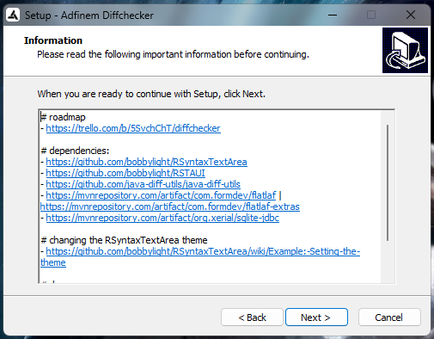](https://private-user-images.githubusercontent.com/43742265/482819596-b3319547-3884-42b3-ac2c-f54fc1917bee.png?jwt=eyJ0eXAiOiJKV1QiLCJhbGciOiJIUzI1NiJ9..5dnBwRFdfagyL8JcCZudEIcdc-93AbhIS9C6T1n3DRo) [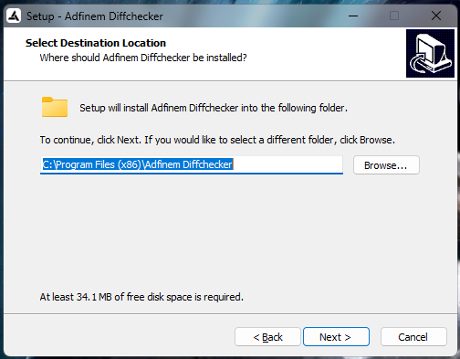](https://private-user-images.githubusercontent.com/43742265/482819784-8a1d3e0d-52f1-49c5-b3a5-4facd22549f2.png?jwt=eyJ0eXAiOiJKV1QiLCJhbGciOiJIUzI1NiJ9..H692O5YGsQ1SfdcUgVByjf0OCQ0ZJjqhu4rqUw3ccmY) [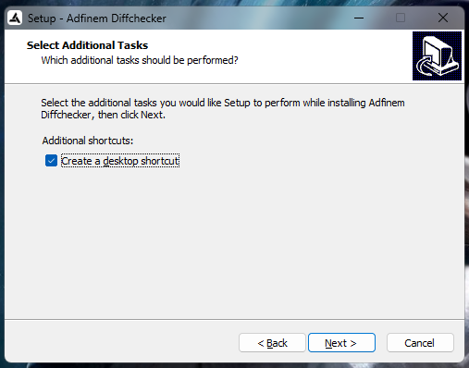](https://private-user-images.githubusercontent.com/43742265/482819897-5f66c27b-0ebb-41e9-98e4-803d6095d0af.png?jwt=eyJ0eXAiOiJKV1QiLCJhbGciOiJIUzI1NiJ9..NJF7tJF1Mr5w0NK9YJISEQie5DTCkz8m0EYg7B8l9UQ) [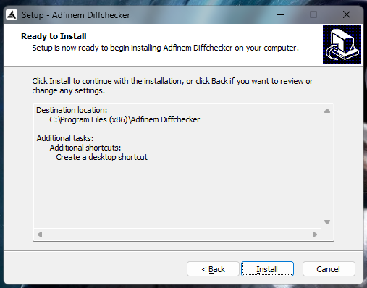](https://private-user-images.githubusercontent.com/43742265/482820009-2a57832b-3fb2-4c31-8634-8b7e0fcece7e.png?jwt=eyJ0eXAiOiJKV1QiLCJhbGciOiJIUzI1NiJ9..pxY4TmNQpnxu9IHtT6EQDf1Gw_lr-GGiEj-yPGeLaac) [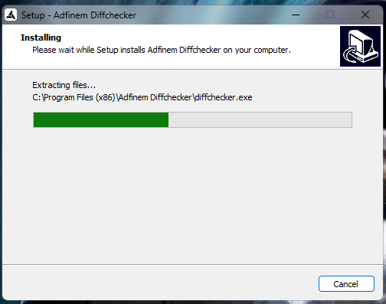](https://private-user-images.githubusercontent.com/43742265/482820776-d99f8fc1-728f-40eb-9755-2e9c8757752e.png?jwt=eyJ0eXAiOiJKV1QiLCJhbGciOiJIUzI1NiJ9..pkyxy7EK8O90vHUwVkFNhUEKW45mpQd9aOA-_ce149o) [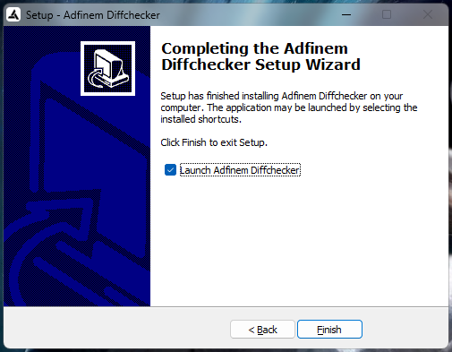](https://private-user-images.githubusercontent.com/43742265/482820151-50e53d72-9ad7-49cc-82e6-9c2c614f622f.png?jwt=eyJ0eXAiOiJKV1QiLCJhbGciOiJIUzI1NiJ9..44zxvbtY9y4Y__TuHPZCjLPHkpuJIh9ca6nHk1otiZQ)

# Video Demo:

<https://www.youtube.com/watch?v=f4yTybuBwkg>